**ITP Dashboard:** ITP Dashboard is custom trading dashboard, designed and launched using Pentaho Business Intelligence Software.

**Purpose:**

1. To show the trade recommendation on a daily basis.
2. To show the trading portfolio based on generated 15 strategies.

**ITP Recommendation:** Provides the Buy and Sell recommendation for the next day trading.

Historical Data: Show Short, Long, Net for the last two days.

Recommendation: Shows the generated recommendation for the next day trading.

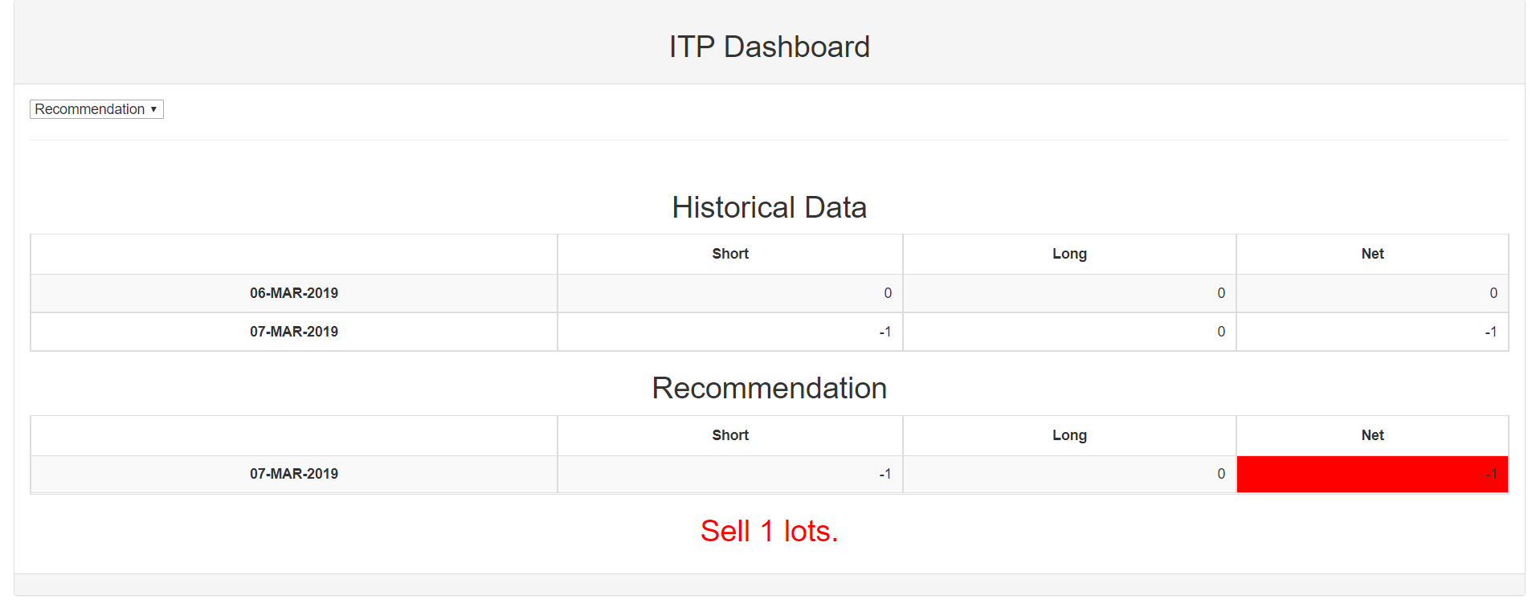

Above image shows the demo of the recommendation to **sell 1 lots** for the next day trading.

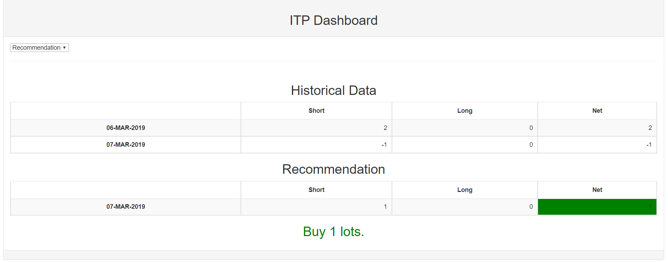

Above image shows the demo of the recommendation to **buy 1 lot** for the next day trading.

**Reporting:** Shows the portfolio report for each strategy under the tab of reporting.

We have calculated number of Key performance indicators for each strategy as shown in the image below:

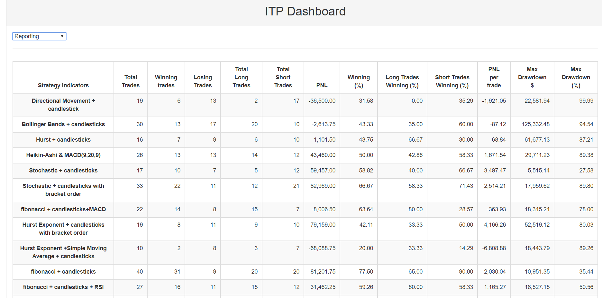

**Useful Commands:**

**For Pentaho backup:**

import-export.bat --backup --url=http://localhost:8080/pentaho --username=admin --password=password --file-path=D:\pentaho-server-ce-8.3.0.0-371\download\backup.zip

**To Restore the backup:**

import-export.bat --restore --url=http://localhost:8080/pentaho --username=admin --password=password --file-path=c:/home/Downloads/backup.zip --overwrite=true --logfile=c:/temp/logfile.log

**Latest version of the packages:**

|  |  |  |
| --- | --- | --- |
| Package/Libraries | Dependencies /Minimum Requirement | Working Version |
| Python |  | Python 3.7.3 |
| Backtrader |  | 1.9.70.122 |
| backtrader_plotting |  | 0.5.3 |
| Bokeh |  | 1.0.2 |
|  | CPython versions 2.7 and 3.5+ only. |  |
|  | Jinja2 | 2.1 |
|  | numpy | 2.1 |
|  | packaging | 18 |
|  | pillow | 5.3.0 |
|  | python-dateutil | 2.7.5 |
|  | PyYAML | 3.13 |
|  | six | 1.12.0 |
|  | tornado | 5.1.1 |
|  |  |  |
|  |  |  |
| Matplotlib | 1.4.1 | 3.0.3 |
|  |  |  |
| Pyfolio | Only test python 2.7 and 3.6. | 0.9.0 |
| pandas |  | 0.23.4 |

**List of modified files in pyfolio Library:**

|  |  |
| --- | --- |
| **File Name** | **Method Name** |
| [tear.py](http://tear.py) | create_full_tear_sheet method  create_returns_tear_sheet |
| [plotting.py](http://plotting.py) |  |
| [round_trips.py](http://round_trips.py) | extract_round_trips  gen_round_trip_stats |